Day 5

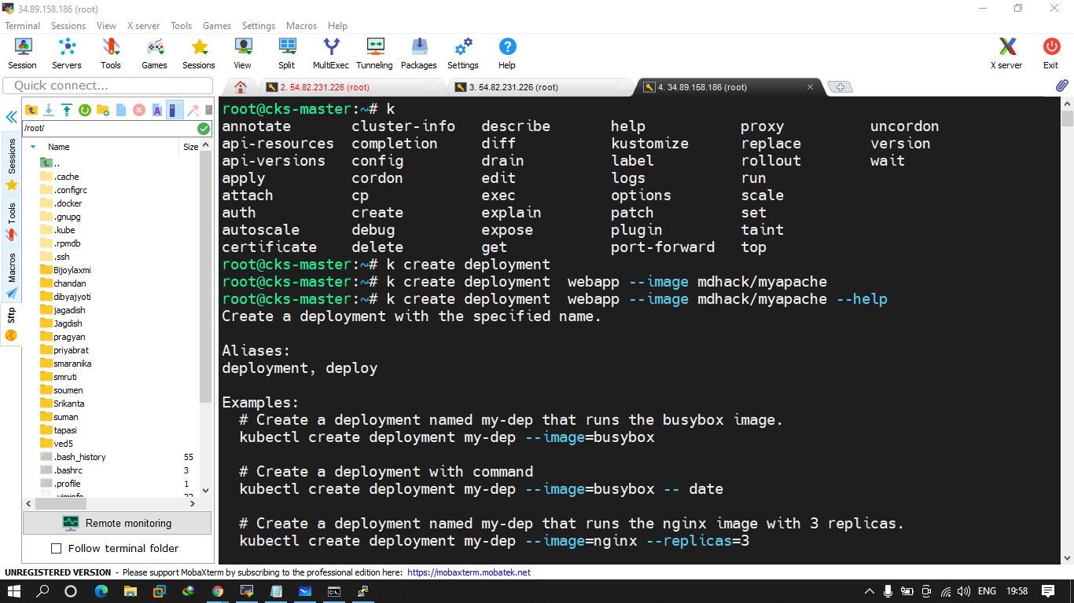

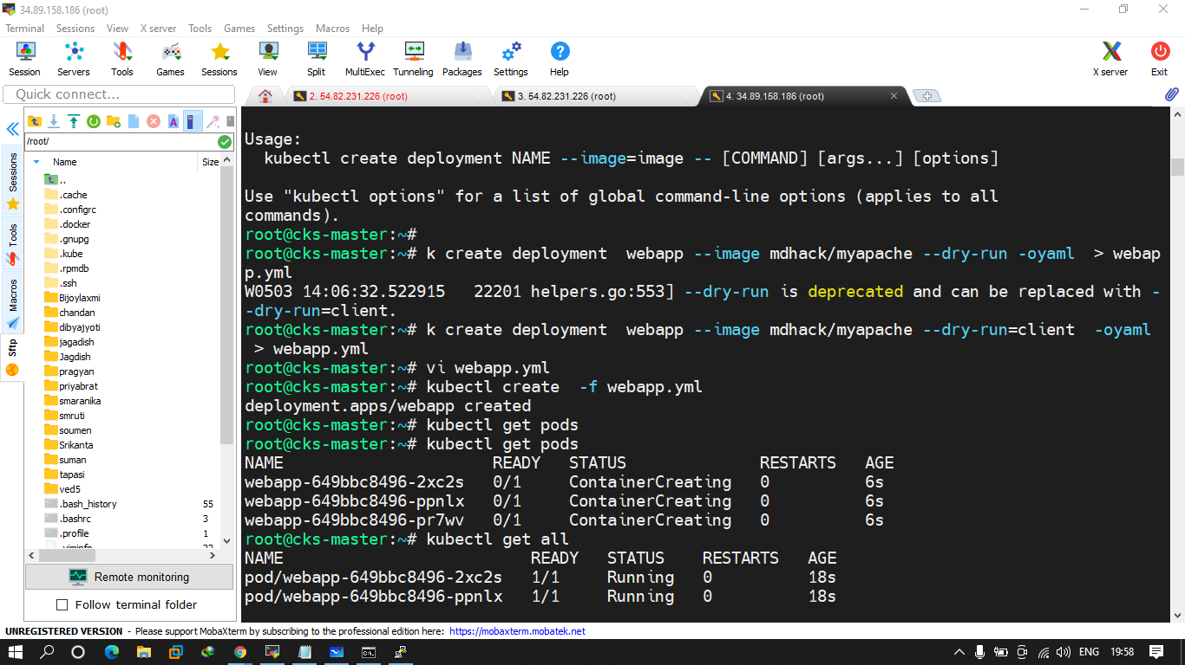

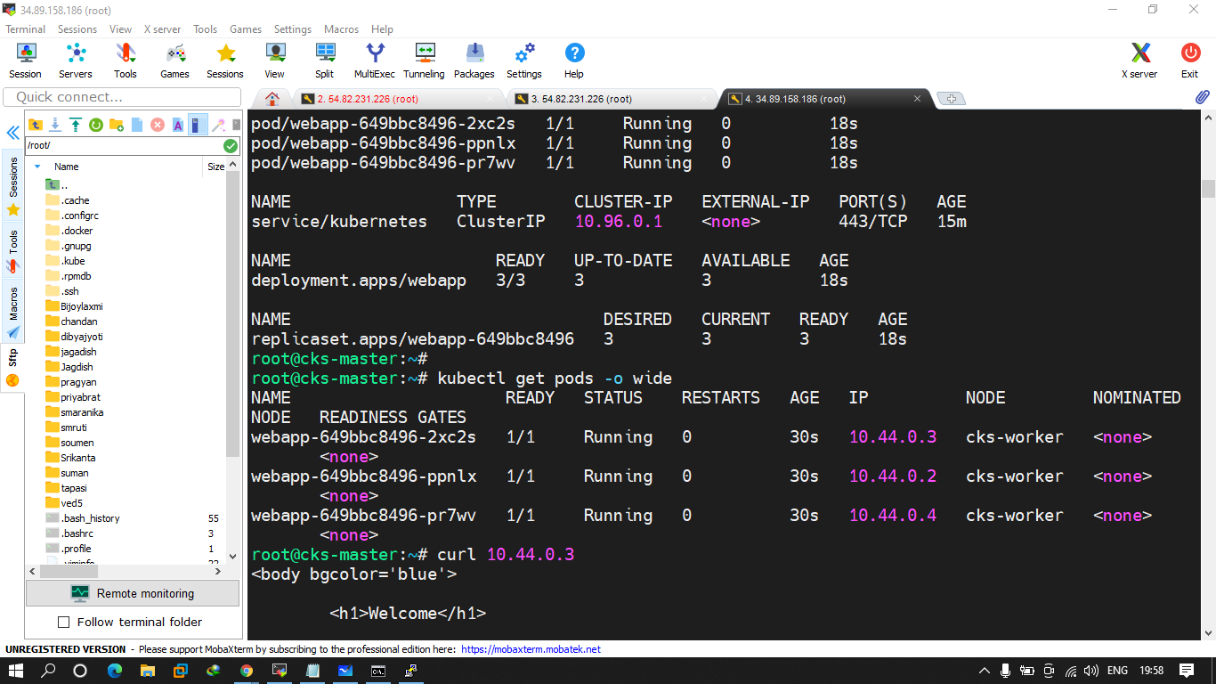

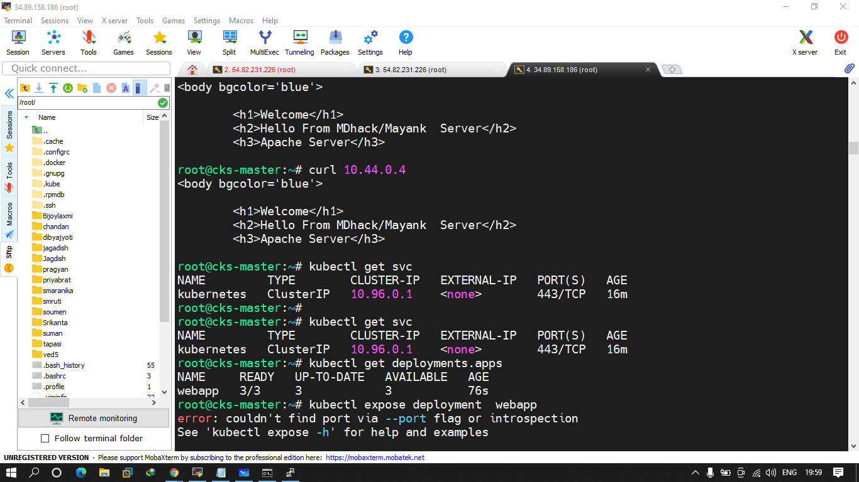

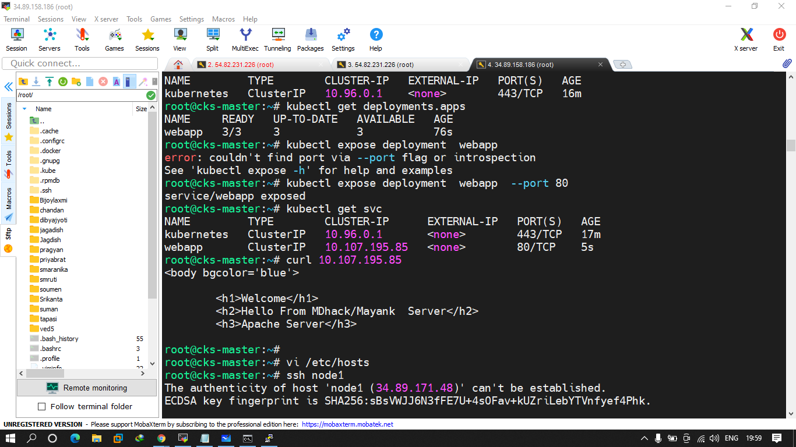

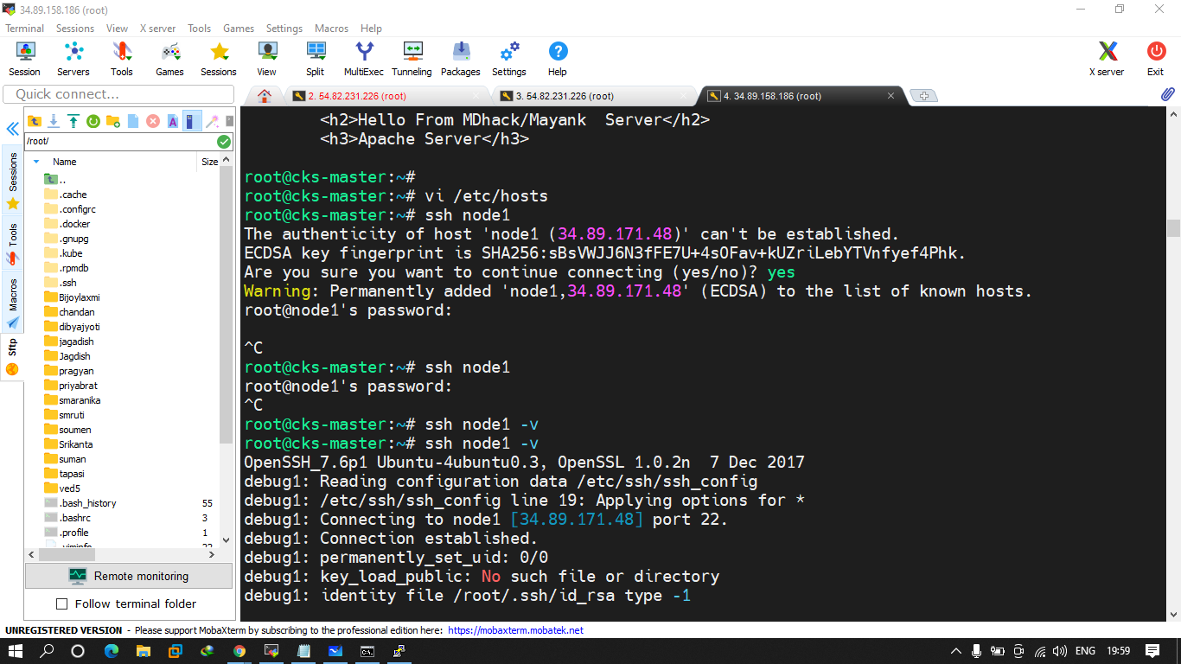

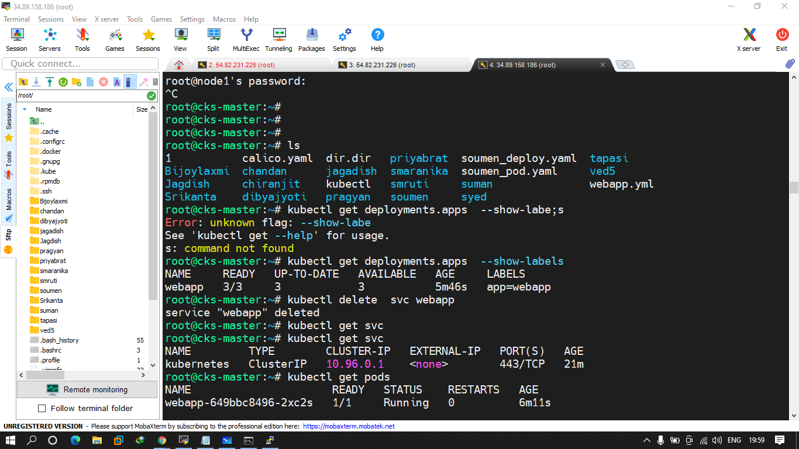

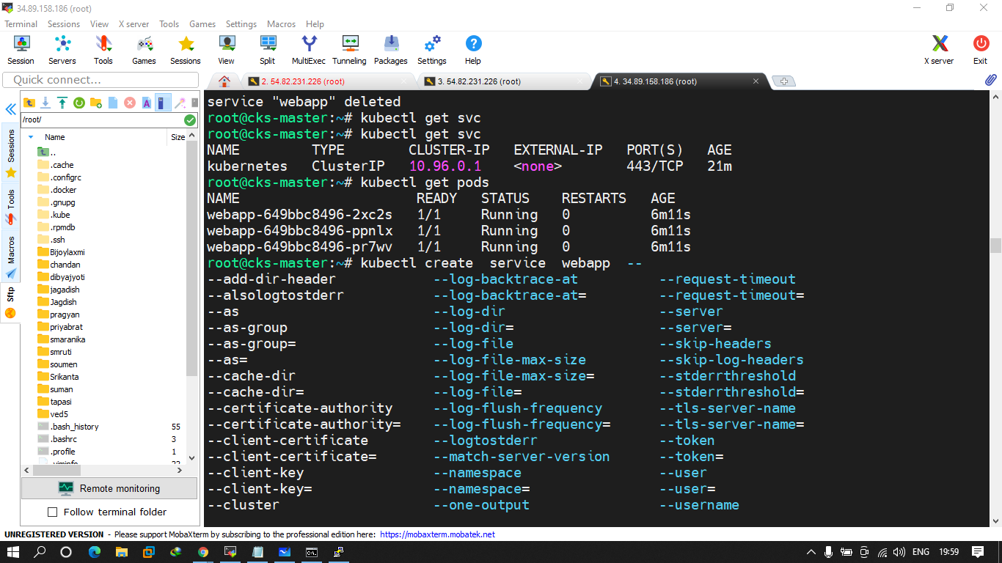

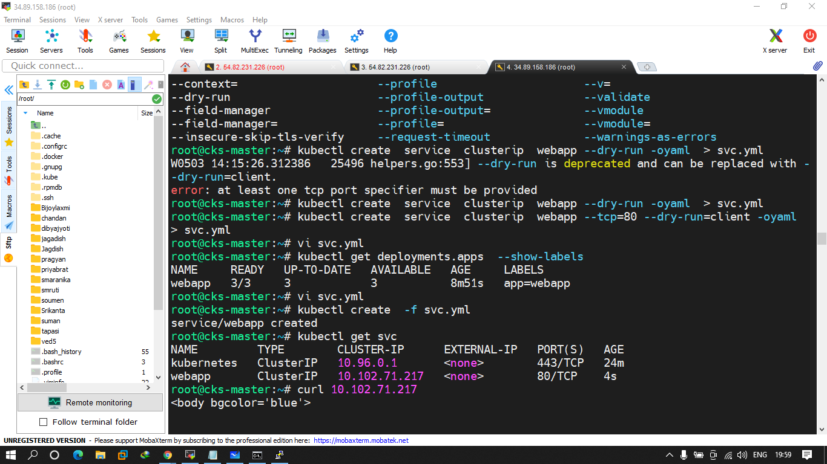

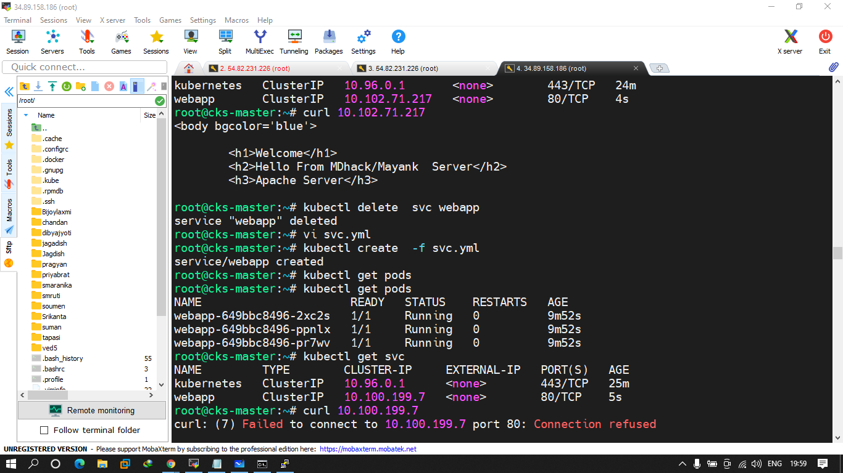

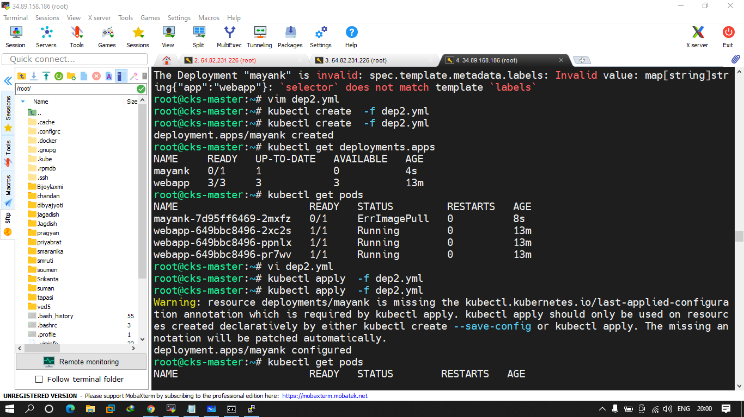

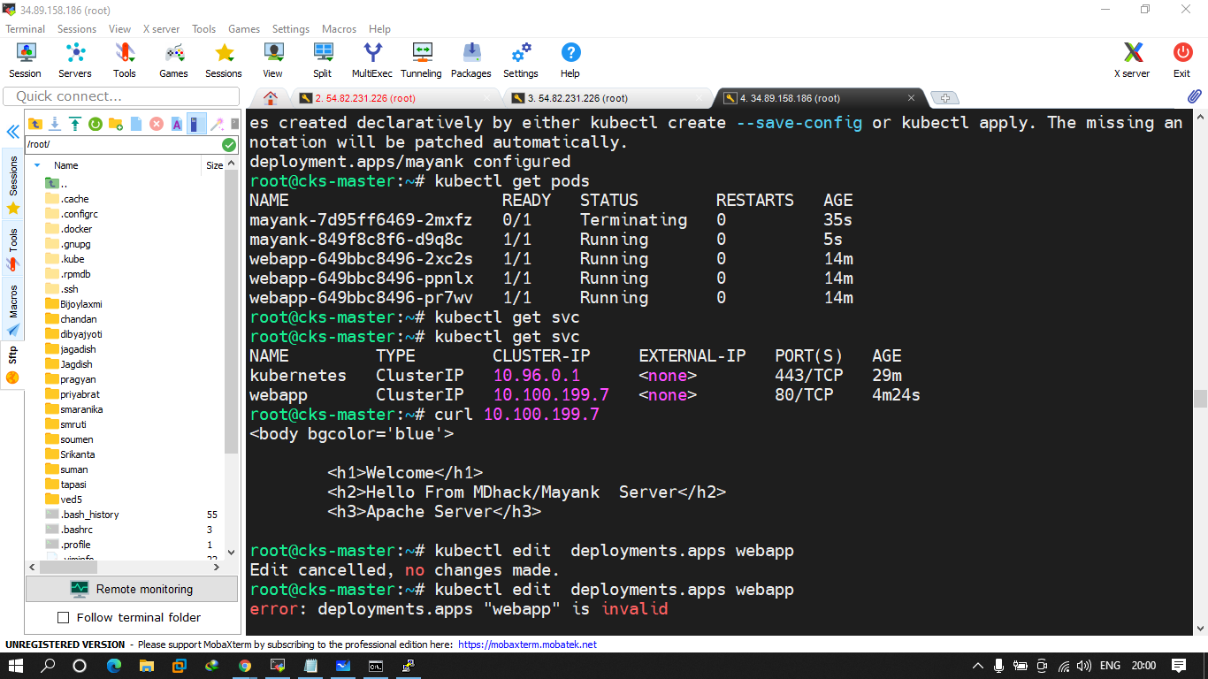

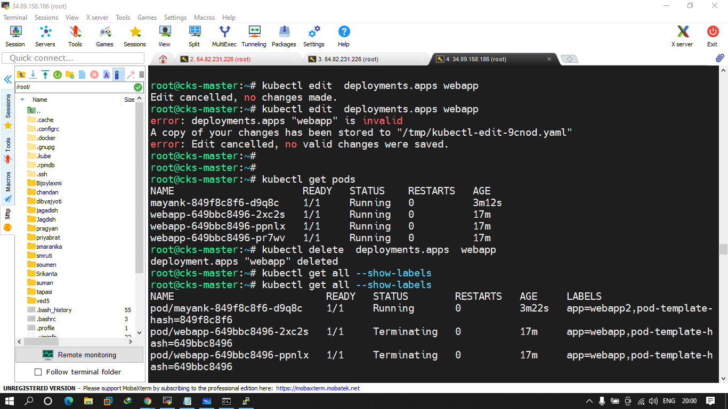

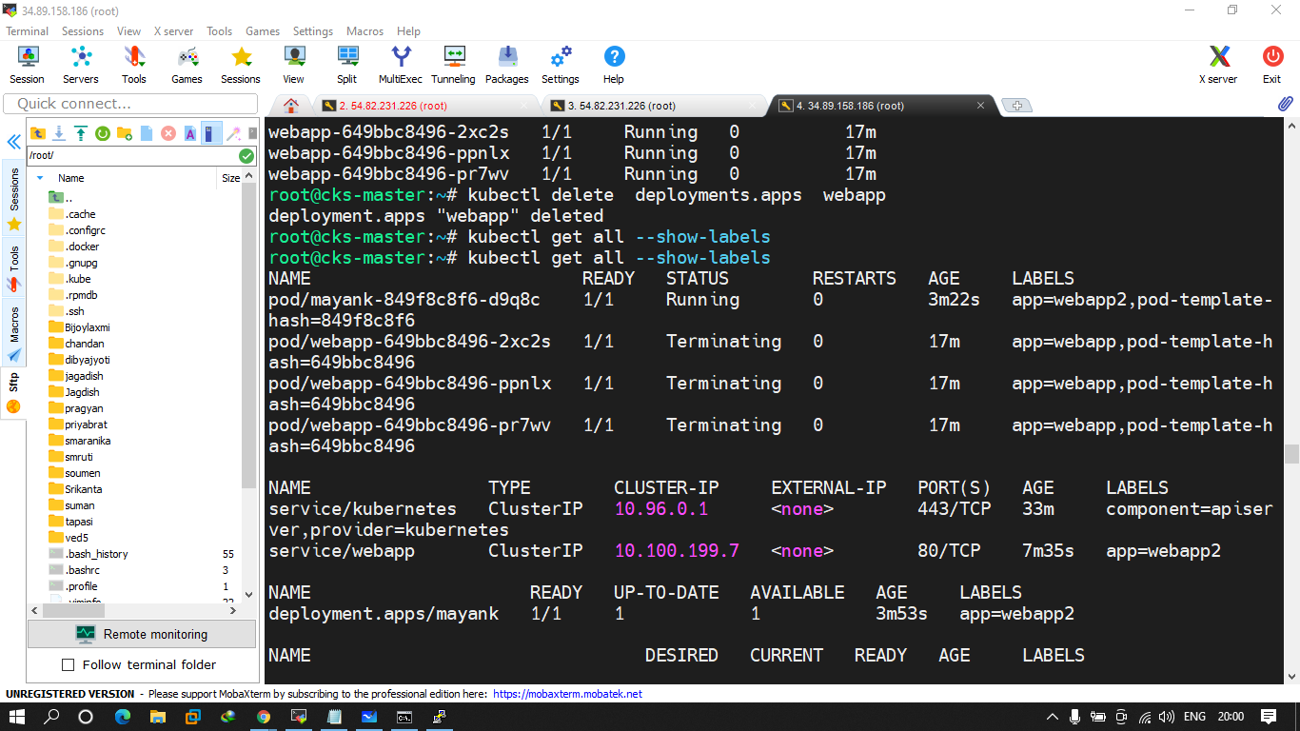

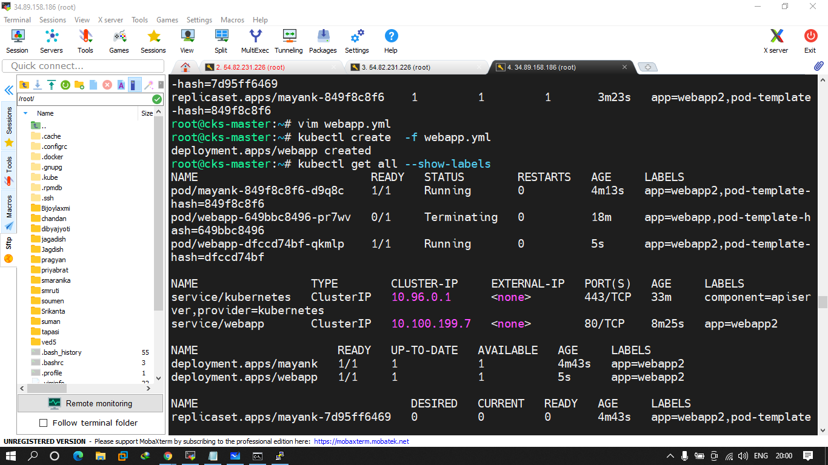

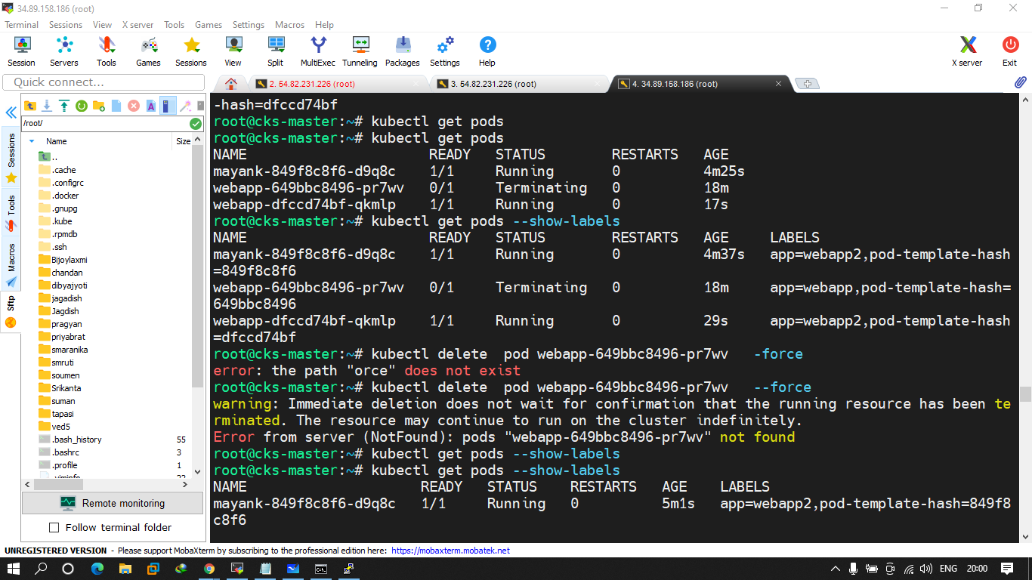

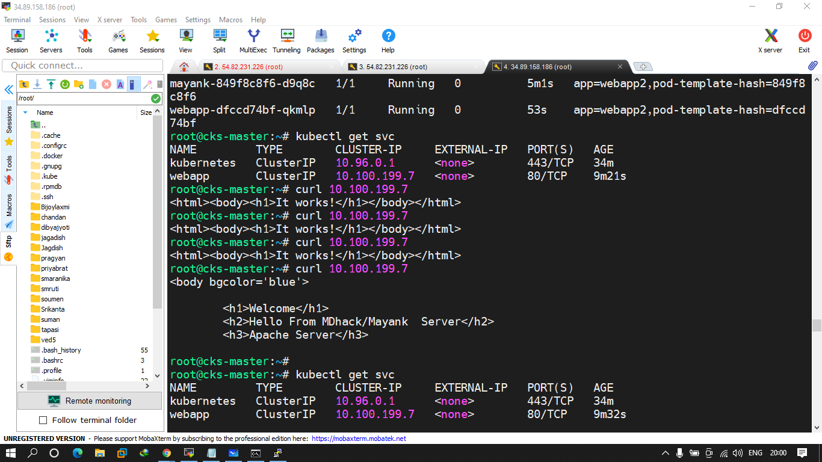

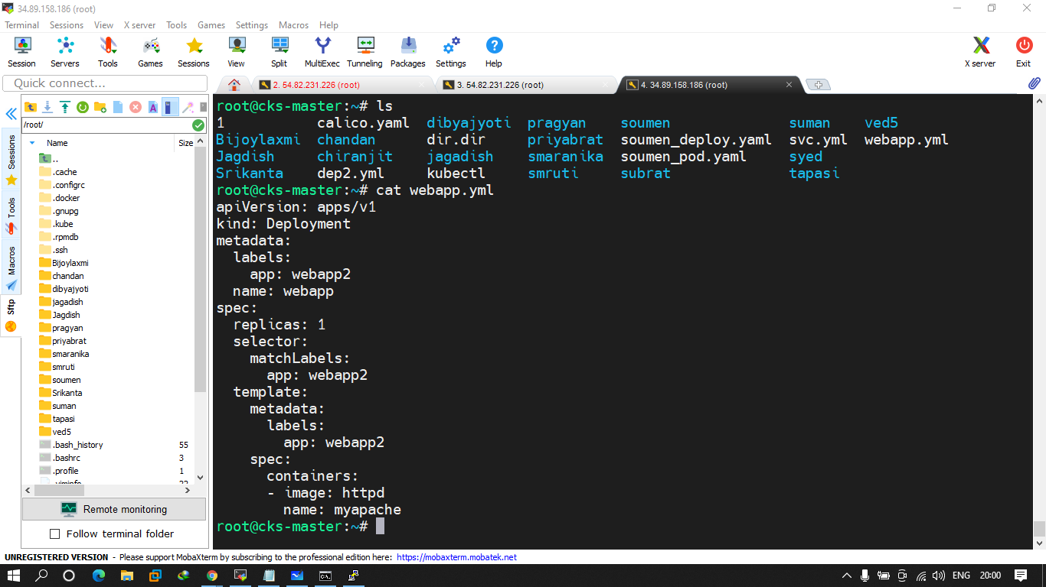

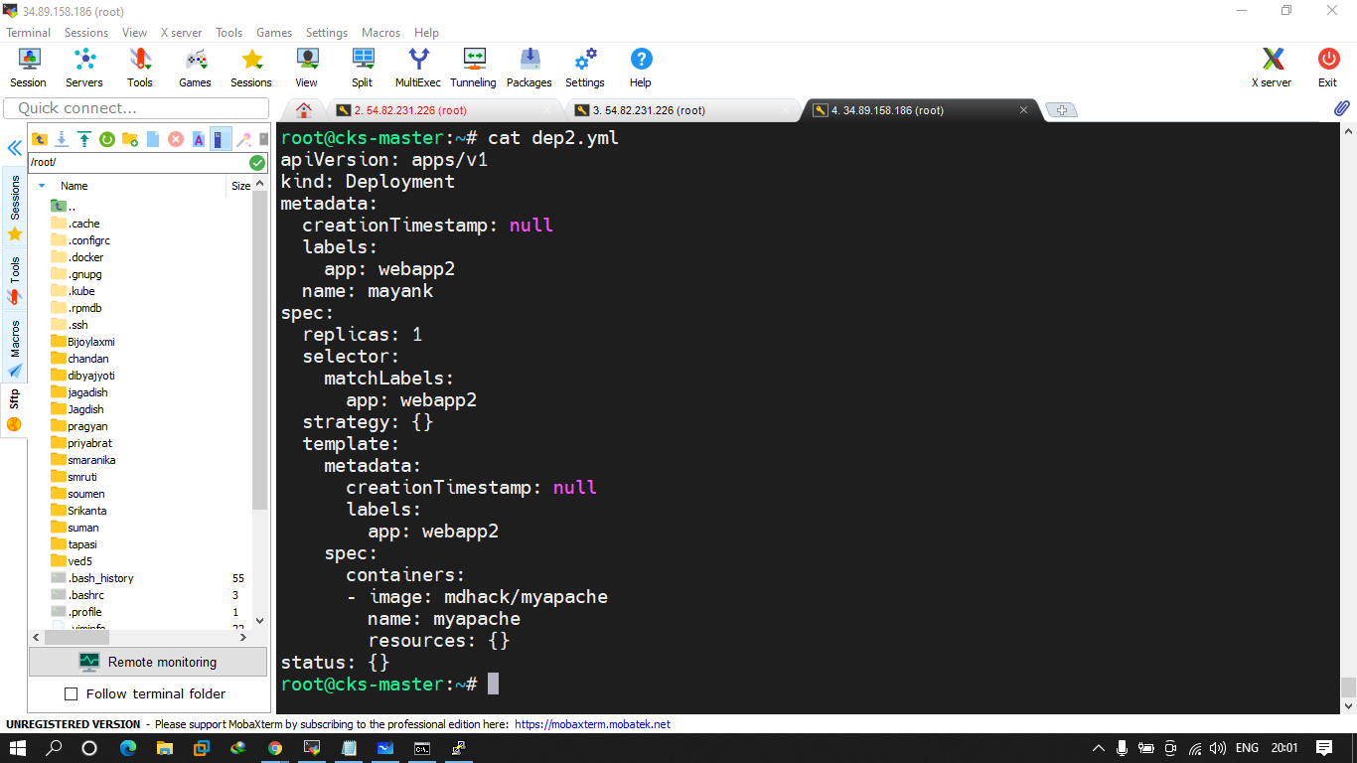

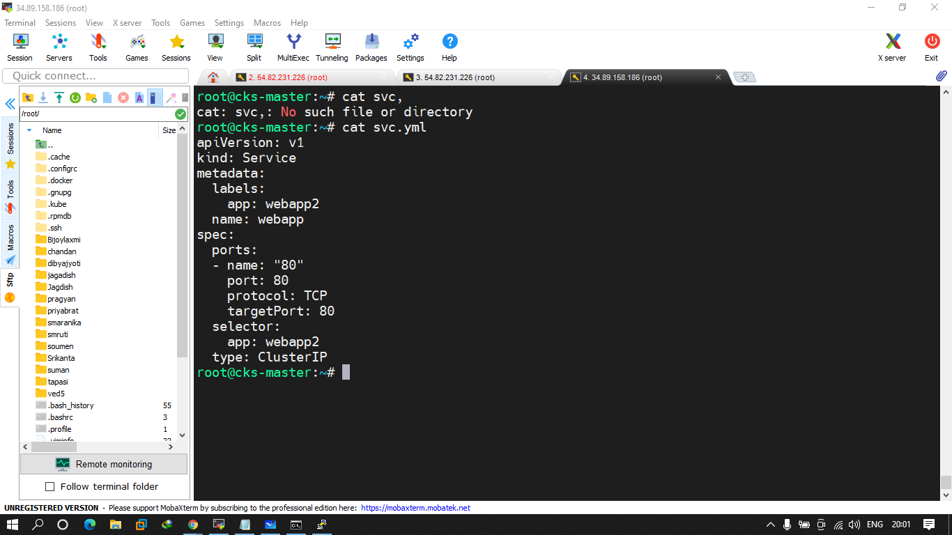

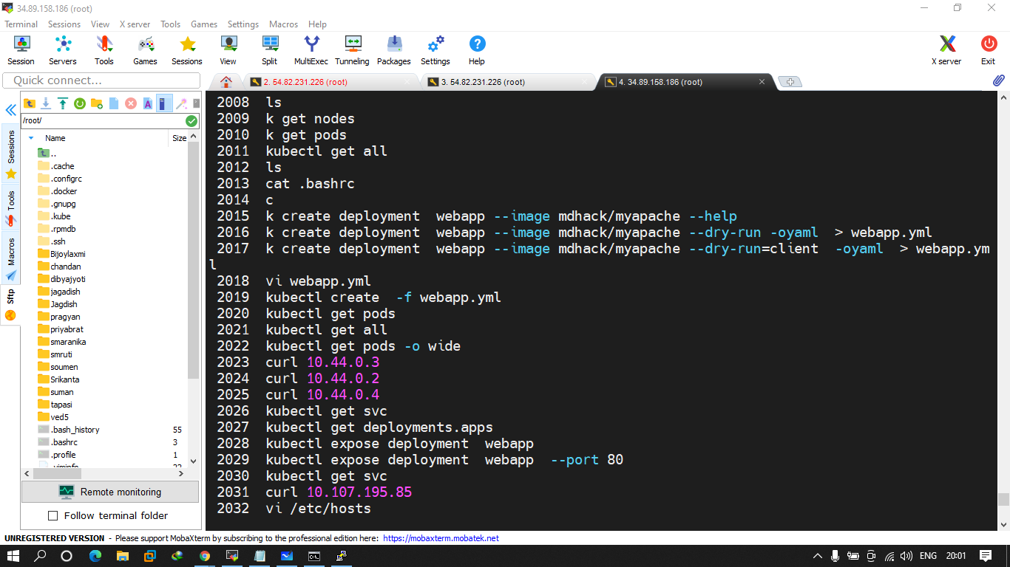

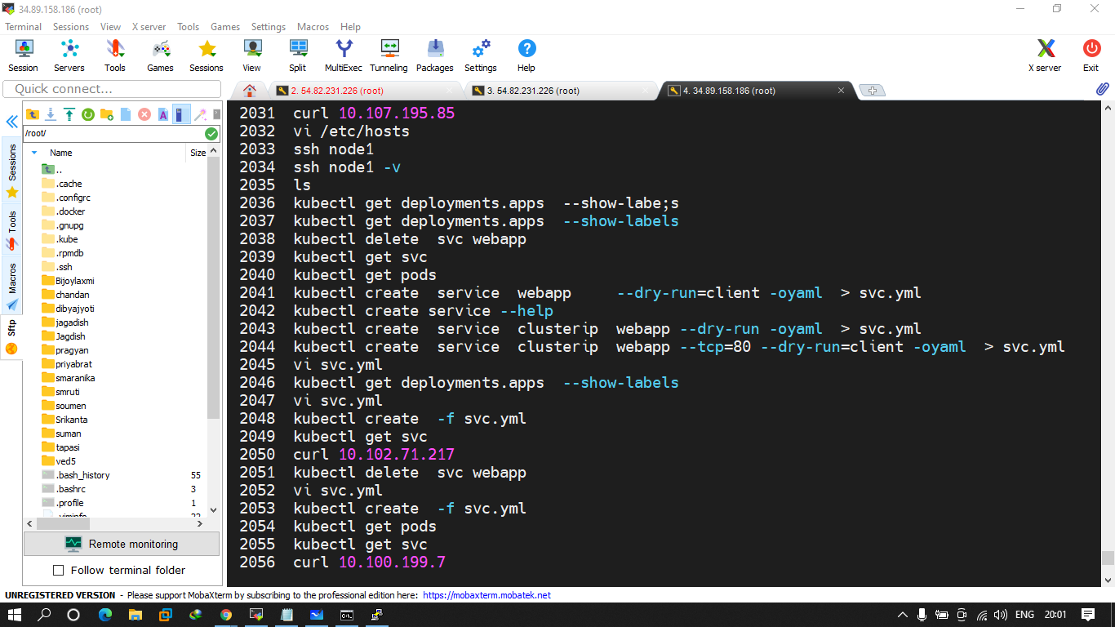

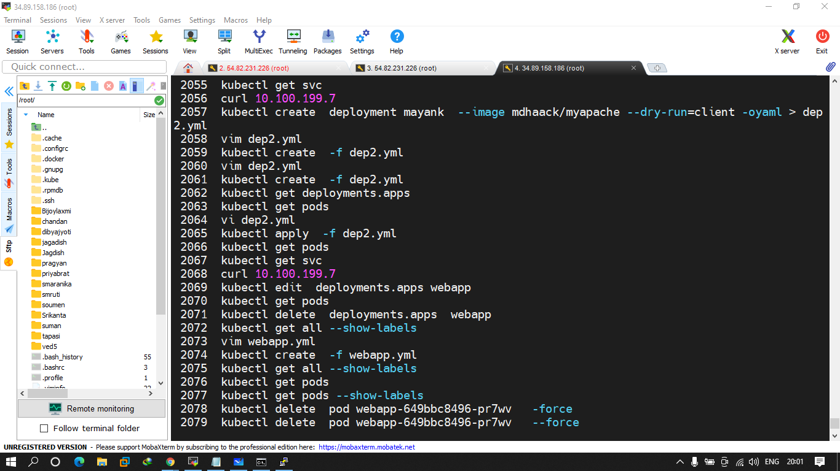

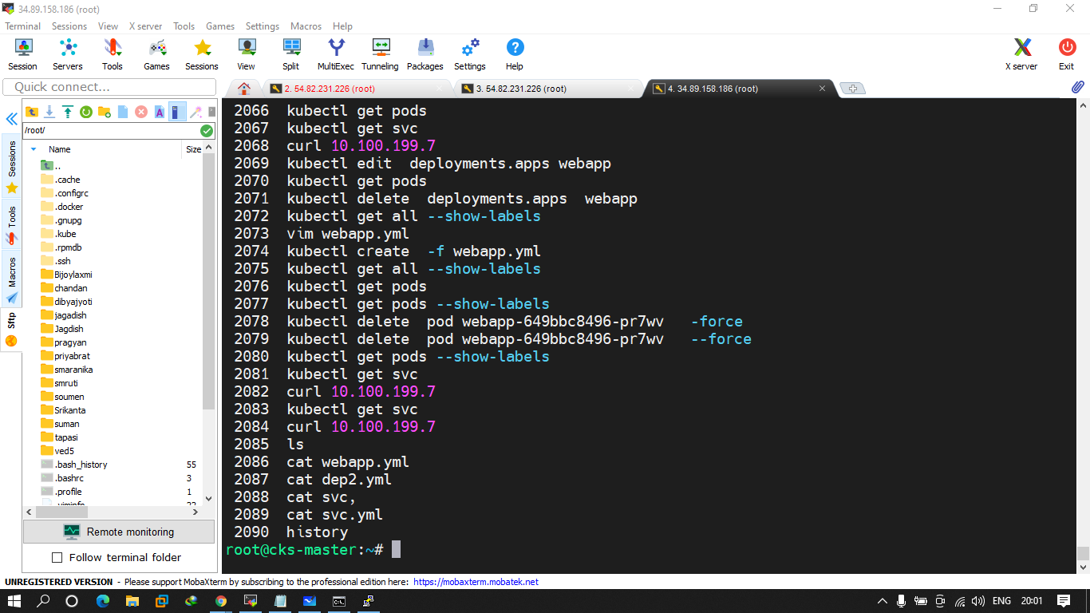

Q.1 try to create deployment using mdhack/myserver image and 3 replicas should be running and label is env=prod after that expose it to a service type clusterIP and access it by using clusterip

Q.2 CREATE A DEPLOYMENT using mdhack/simple-webapp nad 1 replicas with label app=mayank and create a yaml of service to expose it on clutserip.

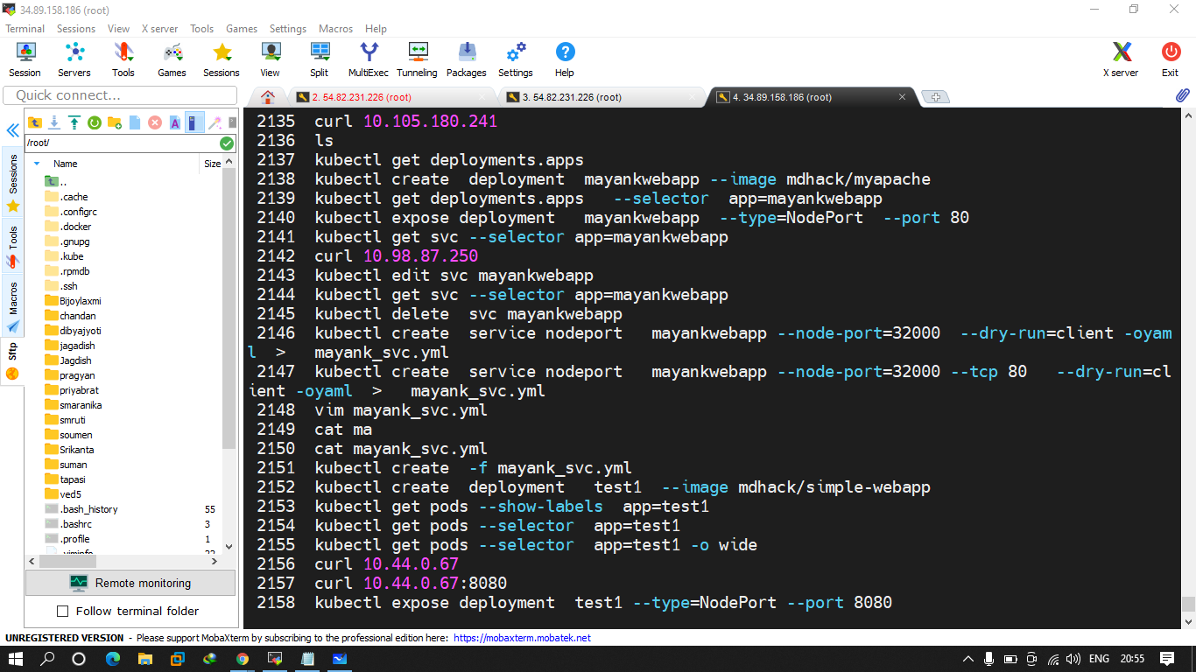

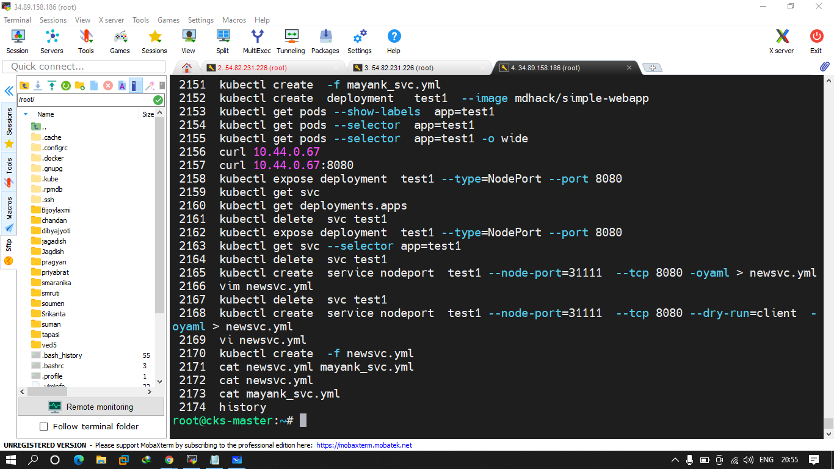

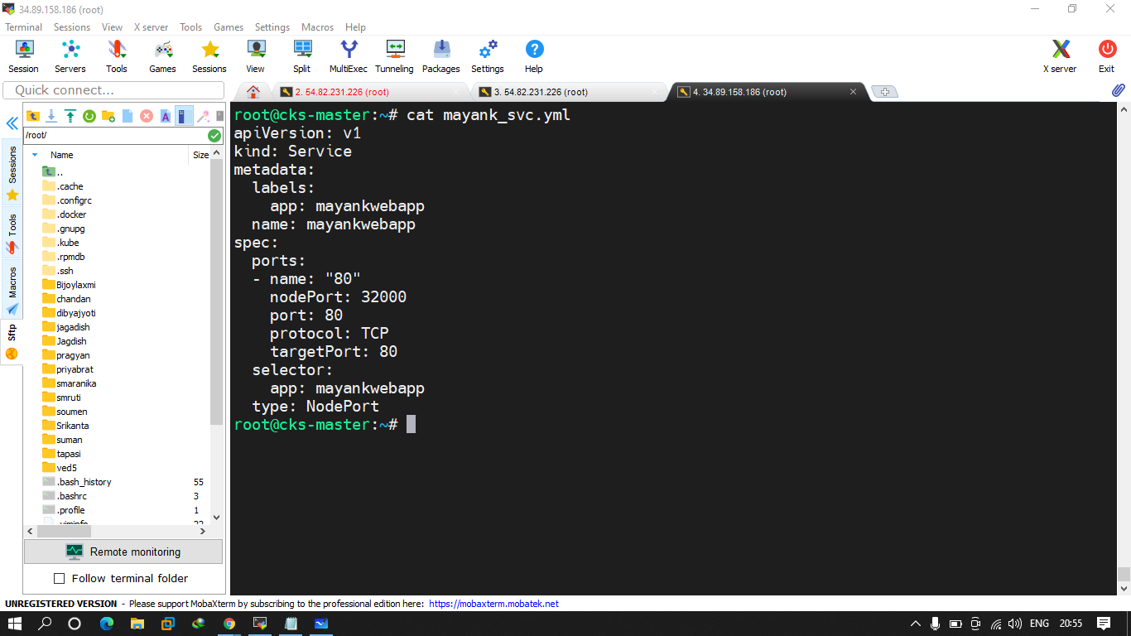

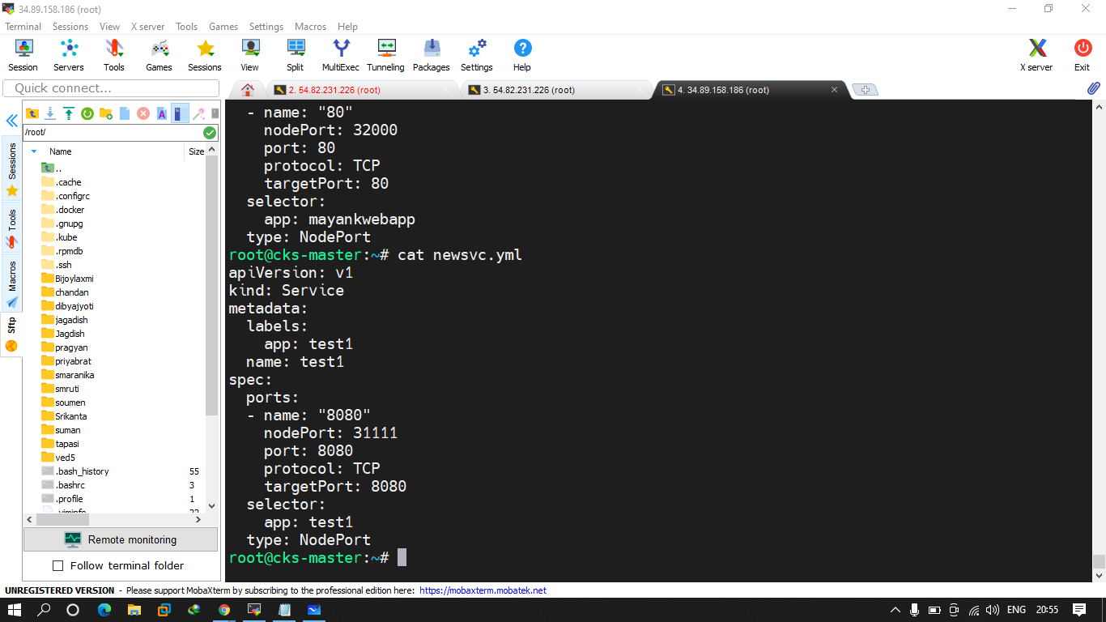

Q.1 create a deployment using mdhack/simple-webapp image and expose it to any port no.

Q.2 create a deployment using mdhack/myapache image and expose it to any port no. but using yaml of both.

ectl delete ns mayank

2212 vim pod.yaml

2213 rm -f pod.yaml

2214 vi pod.yml

2215 cd

2216 cat mayank_svc.yml

2217 cd mayank

2218 vi pod.yml

2219 kubectl create -f pod.yml

2220 kubectl delete ns mayank

2221 kubectl delete pod multicontainer

2222 vi pod.yml

2223 kubectl create -f pod.yml

2224 kubectl get pods

2225 kubectl get pods --show-labels app=multicontainer

2226 cat pod.yml

2227 kubectl describe pod multicontainer

2228 kubectl delete all --all

2229 kubectl create -f pod.yml

2230 kubectl delete svc mayank

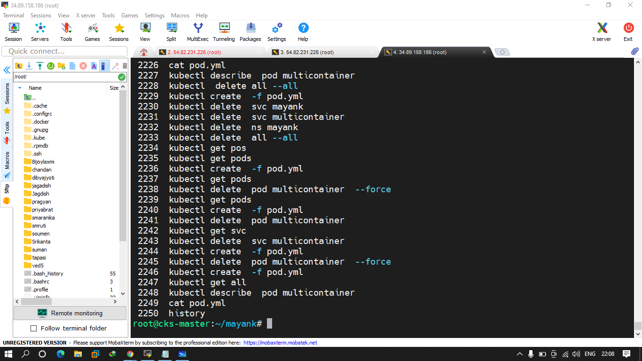

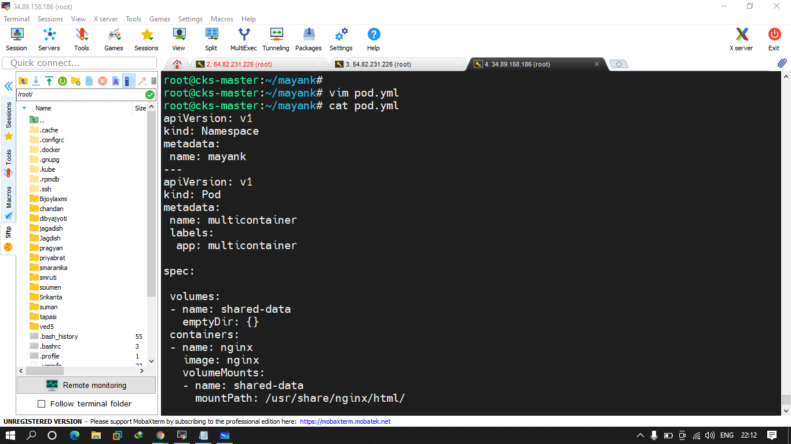

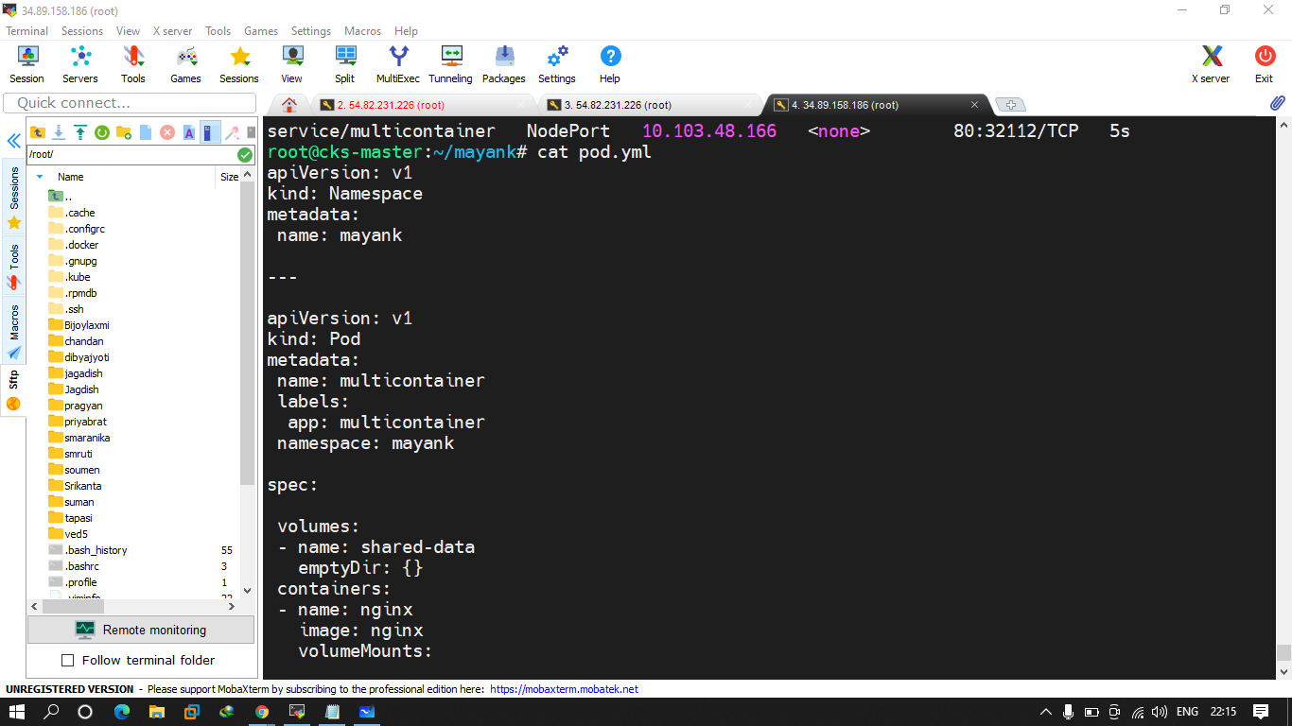

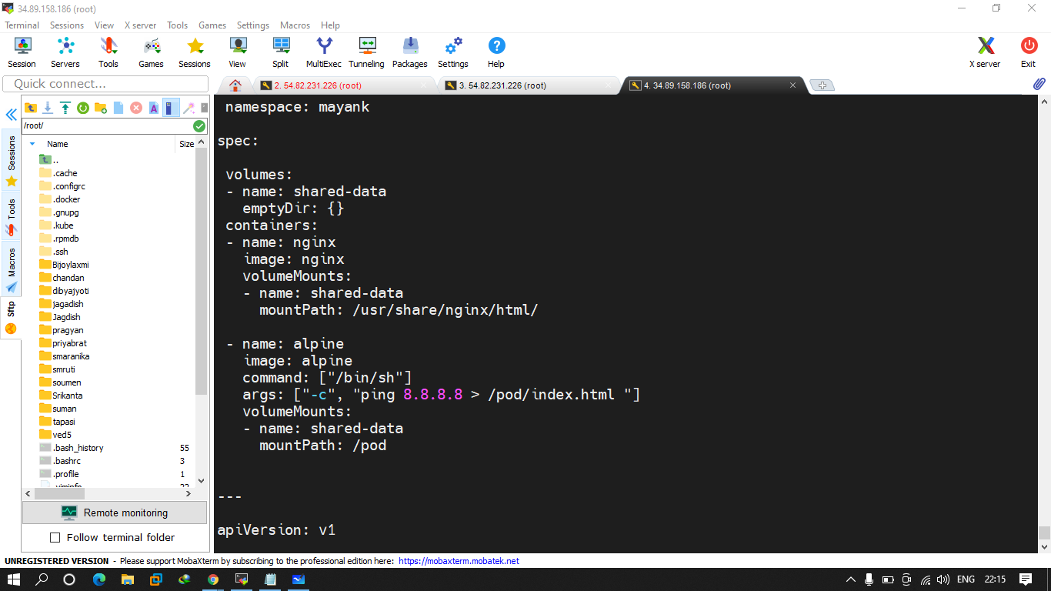

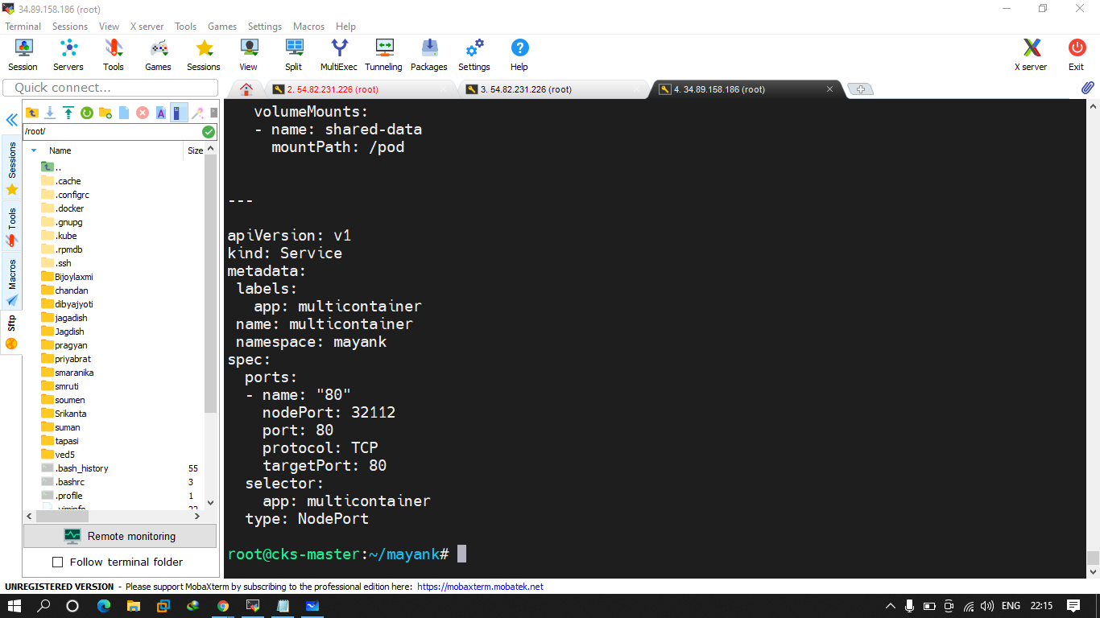

Q.1 create a ns with ur complte name using yaml

Q.2 create a pod using nginx and alpine image where alpine is giving u output of date command in correct location and u have mount that to nginx image and output shoud be date command . and expose that on nodeport (random port no. )